**Date:18th, 08,2025**

**Report on Task Management System**

**Task Reminder System**

**Introduction**

This report presents the development of a **Task Reminder System** implemented using Bash shell scripting. The system was designed to manage tasks through command-line interaction and basic file handling.

**Objectives**

* To create a simple task manager capable of adding, viewing, and removing tasks.
* To implement error handling for invalid or empty inputs.
* To integrate a **daily reminder mode** using cron scheduling for task notifications.

**Implementation**

The script stores tasks in a text file **(tasks.txt)** and provides menu-driven options for user interaction. It uses Bash functions for modularity, sed for task removal, and cat for listing tasks. Automation is achieved by scheduling reminders through crontab.

**Challenges**

* Ensuring **input validation** was a challenge, as empty or invalid entries needed to be handled carefully.
* The sed command for task removal required precise syntax to avoid unintended deletion.
* Setting up cron jobs correctly depended on the environment, making testing slightly difficult.

**Recommendations**

* Future improvements could include **task prioritization** (e.g., high/medium/low) to better organize tasks.
* Integration with **email or desktop notifications** would make the reminder system more effective.
* Expanding the script to support **task deadlines** could provide a more comprehensive productivity tool.

**Conclusion**

The project demonstrates practical skills in **Linux shell scripting, automation, and file management**. It provides a simple yet effective system for daily task tracking and reminders, showcasing how scripting can be applied to real-world productivity solutions.

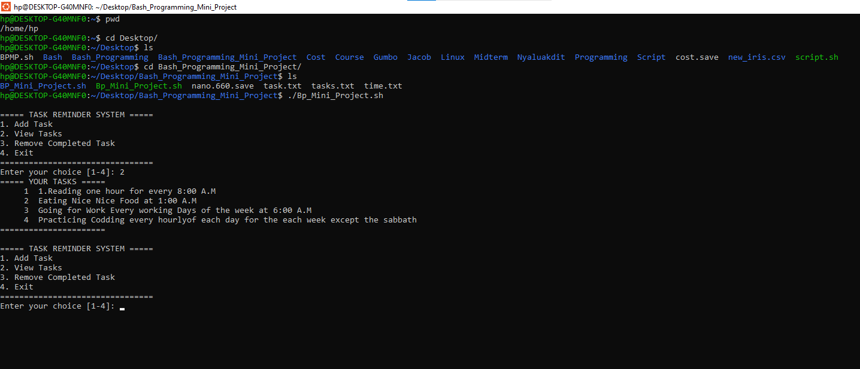 **Tasks Showing the Procedures for Opening and View Tasks Here**

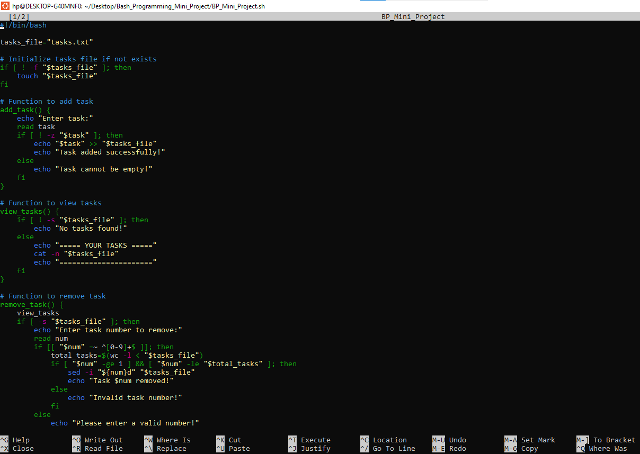**The code the .sh terminal**

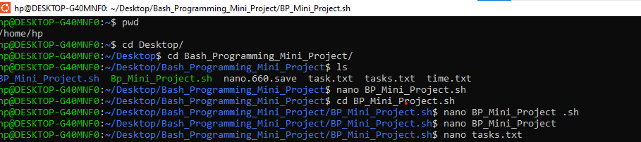

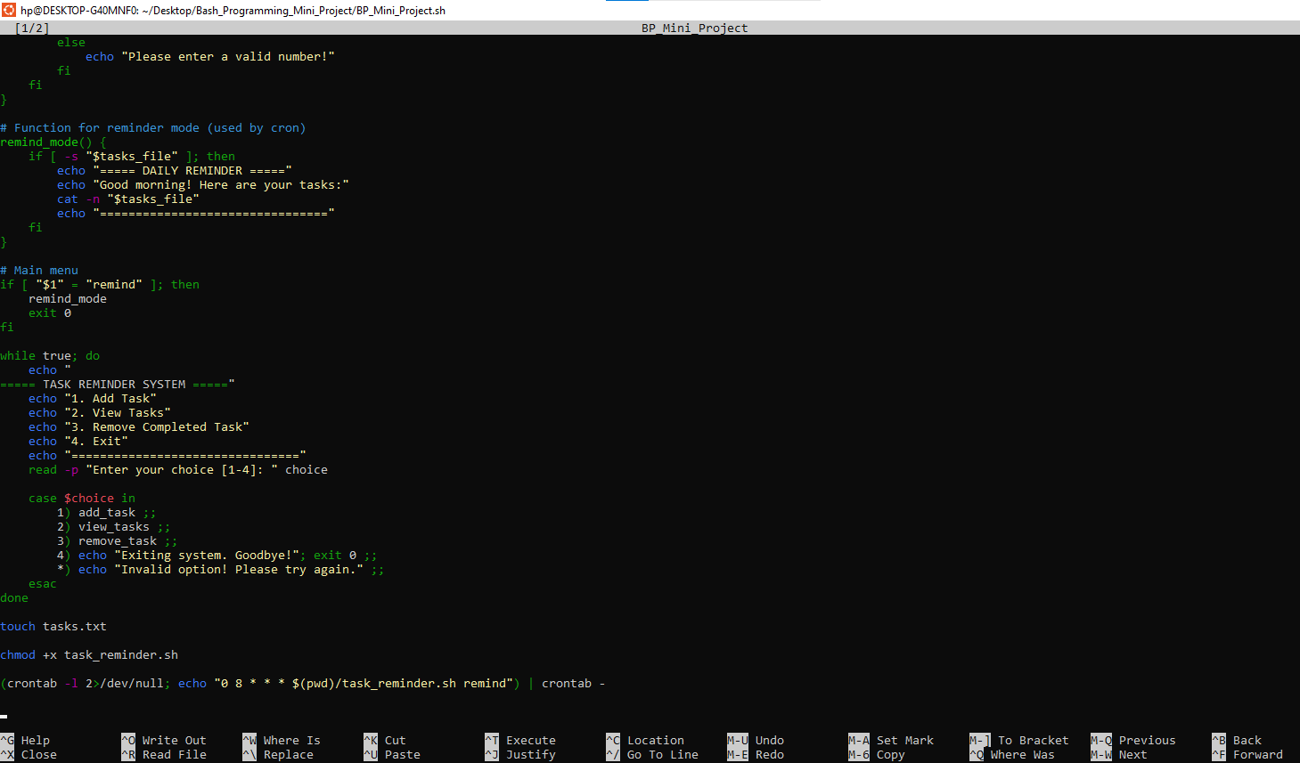

**This part was the b trial for the four steps. I have implemented them using Using Different Task that I have removed**

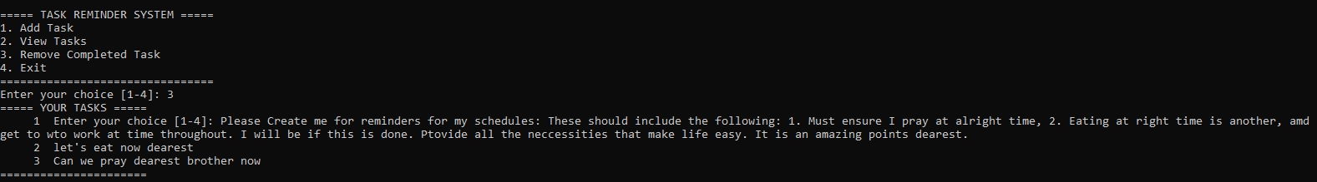**Displaying the Number of the tasks that are the created**

**Show** **Task to Remove of Task 2 Here**

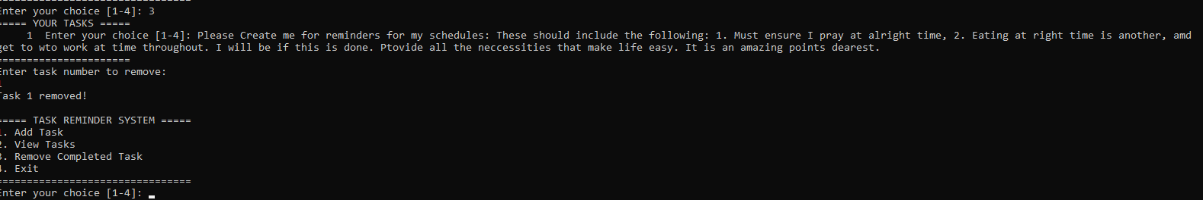**Showing Removal of Task 1 Here**

**Showing Removal of Task 2 Here**

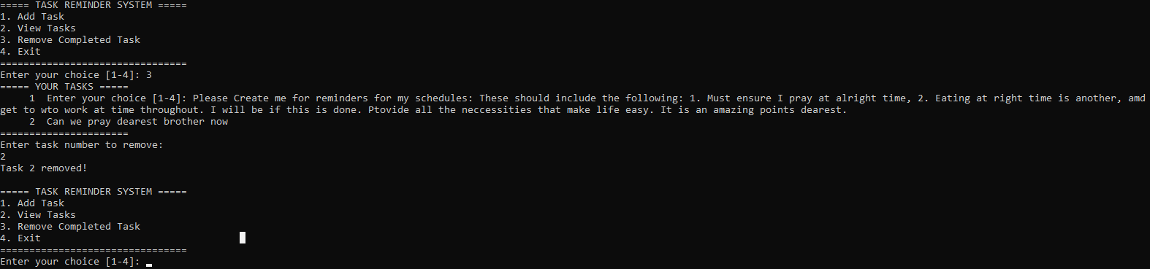

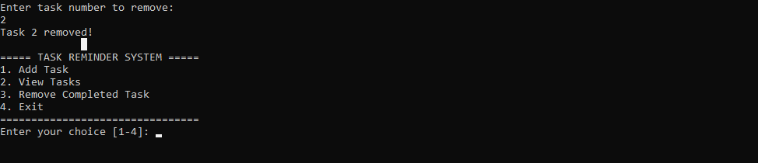**Showing Removal of Task 2 Here**

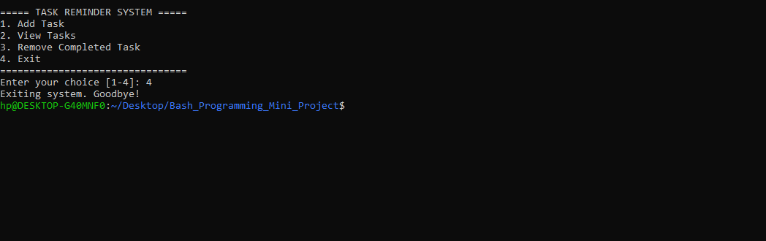**Showing Exit Here**